HYDROGEOLOGY IN THE VALLEY ABURRA

MEMBERS:
ELIZABETH HERNANDEZ CANO
SANDRA PATRICIA PALACIO QUIROZ

JAIRO CALDERON

UNIVERSITY AT ANTIOQUIA
FACULTY OF ENGINEERING
ENVIRONMENTAL SCHOOL

MEDELLIN
2014

Index
INTRODUCTION 2
Objectives 3
1. Importance of groundwater in the Aburrá Valley 4
1.1. Background. 4
2. Geologic units. 5
2.1. Dunite 5
2.2. Hill slope deposits (Qd, Girardota, Bello, Barbosa) 6
2.3. Alluvial deposits (Qal, Qat) 7
3. Water balance. 8
4. Hydrogeological model 10
4.1. Units 10
4.2. Flow Network 11
4.3. Water properties. 11
4.4. Quality 13
5. Flow Regionals, hydro chemically. 14
6. Management of water resources. 16
Conclusions 19
Bibliography 19

INTRODUCTION

This project is about groundwater and its behavior. Global water resources, trying to meet their availability definitions help understand more clearly the functioning and role in the hydrological cycle it is about the relationship with precipitation, runoff, evapotranspiration and water infiltration. It is necessary to analyze all these factors that influence groundwater recharge, groundwater quality, its natural components and the conditions needs for normal development, so you can more easily visualize its break point. All the above is of great importance since humanity currently undervalues groundwater as an important part of the hydrologic cycle and as it often used in an inappropriate manner, such as for agriculture. This sometimes depletes groundwater resources and upsets the water cycle and many of the biological factors that are related to it. There are no clear methods for the protection of groundwater resources and often it does not have policies and/or plans to help effectively mitigate pollution of this important resource, considering that the tenure implies permanence of many animal and plant species. It is also important to analyze how groundwater has been incorporated into the development or societies, although the climatic consequences are many.

Objectives

- Learn about the factors that influence the functioning of an aquifer.
- Determine the equilibrium conditions for good condition of the groundwaters.
- Analyze the role that play the groundwaters systems in the social and the economic development.
- Inquire about the natural impact that entails the overexploitation of this resource.
- Understand the importance of the groundwaters in the hydrological cycle and the consequences of their deterioration.
- Identify the benefits to be gained from this resource, making a sustainable use of the.

Importance of groundwater in the Aburrá Valley
The importance of groundwater in the Aburrá Valley, as a reserve resource for future supply needs of the population or as an alternative that does less dependent on external sources to the surrounding region, makes recharge areas become strategic areas sustainability of the resource and in that warrant special handling thereof. For this reason and the imminent process of urban growth that is coming, and will continue to be in the north Aburrá Valley, the Metropolitan Area of Aburrá Valley (AMVA) identified the need for protective measures for sources s groundwater.[1].

1.1. Background.
Excessive pumping of groundwater can lead to reduction of it, with serious social and economic consequences. Attempts to limit pumping are commonly based on the concept of safe yield, defined as maintaining a long-term balance between the annual amount of groundwater withdrawn and the annual recharge of the aquifer. This definition is too narrow because it does not consider the rights of users of surface water (water from springs and base flow) and the ecosystems that depend on groundwater (wetlands and riparian vegetation) (Sophocleous, 1997).
Recently, the emphasis has shifted towards sustainable yield (Alley and Leake, 2004; Maimone, 2004, Seward and others, 2006). Sustainable yield a fraction of insurance reserves for the benefit performance of surface waters. There is still no consensus as to what percentage of safe yield must be the sustainable yield. The situation is complicated because it requires the knowledge of several natural sciences for proper analysis. In addition, there are social, economic, and legal considerations that must be taken into account.
The greater the degree of development of underground water, the greater the amounts of charging and discharging captured, and, in the case of a system depressed, the greater the amount of captured storage. The higher the discharge captured smaller the residual discharge. Since all aquifer discharge feed into surface water and evapotranspiration, it is concluded that intensive groundwater development can markedly affect surface water dependent ecosystems and local and subregional and regional groundwater.
However, in the planning process of this territory (conclusion POT's and partial plans) does not have environmental determinants for spatial planning related to the protection of the recharge area of ​​groundwater Aburrá Valley, and that are unidentified areas of these municipalities should actually be classified as conservation for the protection of groundwater (recharge areas), or restrict the types of activities that take place on these sites.

Geologic units.
Importantly, the geological information is a key to the performance of any work hydrogeological exploration input.
Geomorphological units such as alluvial deposits, the Amphibolites the Antioquia Batholith and dunites of Medellin may have favorable conditions to storage area in the soil and subsequent infiltration. Several topographic courts to identify and locate areas where relief features are favorable for the temporary storage area of surface water; these features are basically the highland areas and steps or rungs that are mainly due to structural controls that are performed.

2.1. Dunite
The dunites of Medellin, ranked in some of their facies as pseudokarst, undoubtedly constitute a relevant hydrogeological unit in terms of groundwater flow; it should be explored in the future using new methodologies of exploration. In order to determine the possible use of water in it that percolate through infiltration galleries.

2.2. Hill slope deposits (Qd, Girardota, Bello, Barbosa)
Under this designation of deposits you include not lithified landslides and flows of debris and / or sludge by extension allow to be mapped are included. By their thicknesses and maturity are mapped as separate units and not as geological surface formations. The age of these deposits is variable, however the characteristics of height, consolidation, maturity, degree of slope and incision, do let chrono stratigraphic relationships between them, and in the case of flows grouped into series of events.
Within the flows of debris and / or sludge, were identified at least four series of events related to depositional slope deposits, which correspond, from oldest to newest, to Girardota, Barbosa and Bello. These deposits have a tiered or telescopic arrangement, where the oldest are located toward the middle and upper part of the slope and the younger are located towards the base of the slope (Rendón et al. 2006). The geomorphological characterization of the materials that compose the slope deposits was based on parameters such as height range of outcrop, the average slope of the depositional surface, depth and degree of incision of the surface and the overlap between the current drainage pattern and landforms of deposits (Rendón et al.2006). The relations chrono stratigraphic had taken into account, in addition to the aforementioned parameters, stratigraphic markers as paleosols and tephra, where maximum depositional ages based were determined in the dating of volcanic zircons with ages ranging up to Late Pliocene (Rendón et al.2006).

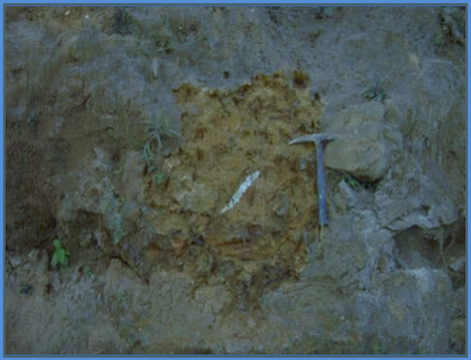
Photo 1: slope deposits. Vereda El Noral. [1]

2.3. Alluvial deposits (Qal, Qat)
Deposits correspond to the background generated by the Aburrá Valley, Medellín River and some of its main tributaries. Recognized by generating a relatively smooth morphology, in some order irregular strips disposed along the flow path, see Picture 2, they may be the type alluvial or wrapping larger dynamic of currents and it defined as aluviotorrenciales.

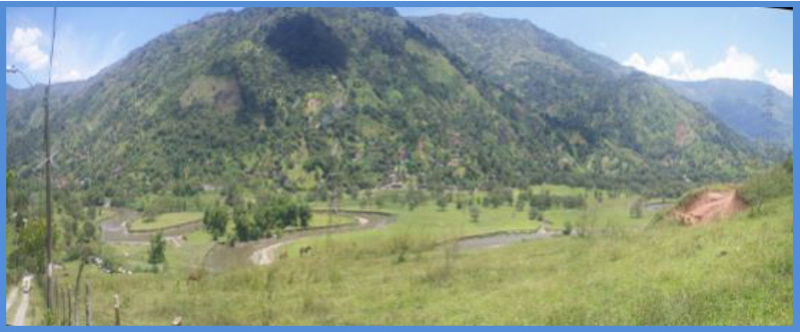
Photo 2: Alluvial deposits. Rio Aburra Associates. [1]

Water balance.
As of a pooled analysis of hydrological records-biotic and physical characteristics of a region, you can define, potentially, the interactions between surface and groundwater, and to estimate precipitation surplus that can potentially feed the underground reservoirs .In the absence of observation networks piezometers levels that allow a direct estimate of recharge to the aquifer units of interest, techniques, and water balance can address the problem of potential recharge indirectly from the hydro meteorological records that are used .This method allows for different temporal and spatial scales, estimating recharge values ​​as excess rainfall, regardless of local phenomena of water exchange with the currents or the horizontal dynamics of surface and subsurface flows. [1].
The geometry of aquifers and aquitards and their hydraulic properties, changes -over time- of the pressure surfaces, the delimitation of areas and sources of recharge and quantification of its free aquifers calculated by the methods of water balance conditions and environmental quality are the elements commonly incorporated into a conceptual hydrogeologic model. The premise that sustainable management of natural resources requires a thorough understanding of means and processes is increasingly rooted in government areas, particularly those relating to the exercise of the environmental authority (Betancur, 2010).
The calculation of the water balance as much in the daily scale for direct recharge, as in the monthly scale for the indirect estimation of potential recharge, develops from the SWB method. In this method the volume control is soil or unsaturated zone.
In this sense, considering the precipitation (P) as the main input stream and as outflows, runoff (Es), actual evapotranspiration (ETR) and the total recharge (Rt).
Δs = P - (Es + ETR + I)
Where (I) is the infiltration and (ds) is the change in storage in the soil. All the variables are in units of flux per unit time (mm in a unit time).
Surface runoff (Es) is calculated by using the method of the Soil Conservation Service (SCS) for abstractions or curve number method applied to daily scale, this described in Chow et. Al, 1999. In order that, are defined a value of runoff curve number for each station (or pixel in the balance distributed) depending on soil physical conditions and land use characteristics, in this study these conditions were extracted of the General Survey Soil and Land Zoning Department Antioquia (IGAC, 2007).

Figure 3: Diagram of runoff.

The Real evapotranspiration is calculated by the formula TURC, from data of ETP obtained in evaporation tank. Once you obtained (Es), infiltration (I) is estimated as the difference between (P) and (Es).

Hydrogeological model

4.1. Units
A hydrogeological unit is a stratum or set of strata adjacent susceptible to recognise by possess similar properties or hydrogeological characteristics (Betancur, 2008) in this regard are: a formation or group of formations of permeable rock saturated with water and a degree of permeability to justify in economic terms, the extraction of underground water resources.

4.2. Flow Network
The water table defines the saturation limit of the unconfined aquifer and coincides with the piezometric surface. From then on this surface it is possible to know the direction that takes groundwater flow, which follows a path perpendicular to the lines of water table equal, from the highest to the lowest.

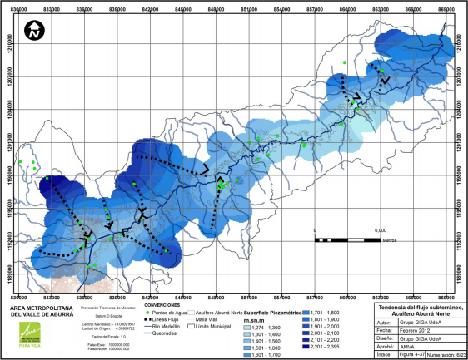 Figure 4: Trend of groundwater flow in the Aburrá Valley.

4.3. Water properties.
For the definition of the hydraulic properties of the aquifer is performed pumping tests, during which are register data that allow calculated through the relation flow-time-reduction-recovery, the values of hydraulic conductivity, storage coefficient and transitivity different units.
When are referring to the hydraulic properties of a hydrogeological unit, are cited three key parameters: conductivity, transmisivity and storage coefficient, the definition of these concepts is stated as:
Conductivity (K): is the ability of an aquifer half to allow flow of water under the effect of a hydraulic gradient (hydrostatic potential difference) per unit length. To provide a measure mechanical of permeability defined the Darcy permeability coefficient (K) which is the volume of gravitic water that flowing during a time unit, under the effect of a unit of hydraulic gradient, through a section unit area perpendicular to the direction of flow and a temperature of 20 ° C.
Hydraulic transmissivity (T): is water volume per unit time (flow) that passes through a vertical section of unit width and of height b, under the effect a unit of gradient hydraulic and a temperature of 20 ° C.
Storage coefficient (S): is the volume of water that is released by a aquifer prism of unit section unit when change of groundwater level occurs.
The hydraulic gradient that refer to these definitions represents the piezometric head loss per unit length. As stated in Darcy's law requires the existence of a hydraulic gradient for groundwater flow, the piezometric surface is the locus representing the groundwater levels and their distribution in space, since it is determine directions of flow and thereby indirectly areas recharge traffic areas and dumping sites. That component, one of the most important of the conceptual models is given by field monitoring and is validated with the use of hydrochemical and isotopic techniques.

Figure 5: Properties water. (Darcy's law, coefficient of permeability, hydraulic gradient).

4.4. Quality
The quality index ICA-AS is designed to assess the quality of groundwater that is wants use for domestic purposes, in relation to Colombian law on the subject. It can be used to determine whether it is possible to consume only water uptake with disinfection treatment, further results of interest to the Environmental Authorities and respective local authorities.
The proposed quality index is constructed from Decree 475 of 1998 where is give the standards for safe drinking water and Decree 1594 of 1984 where is normalizes the parameters for raw waters that require conventional treatment and raw water requiring only occur normalized disinfection. Parameters were selected whose presence by decree 475 of 1998 can directly affect the health of users and altering water quality in regards to chemical and organoleptic criteria that may limit domestic use, these are: fecal coliforms, nitrates, iron, hardness, pH, color and turbidity.
It should be noted that although this index was constructed based on the allowable values ​​for these parameters recorded in Decree 475 of 1998 which was repealed by Decree 1575 and Resolution 2115 of 2007, these values ​​did not change, except for the values of hardness that in the recent regulation is more lax.
The quality index is calculated for ground water according to the following equation:
ICA-AS = Σ (Yi * Pi)
Where:
(Yi) rating value that depends on whether or not the norm
(Pi): weight value of each parameter.
The weight values ​​(P) were determined according to the effects that each parameter has on the quality of water for domestic use, the most critical parameters are fecal coliform and nitrates, for this reason have weights of 0.3 and 0.25 respectively. Turbidity and color affect the aesthetic quality of the water and may significantly limit its use and receive a weight value of 0.12. Also the pH, iron and hardness may limit water use but not so significantly because they have no direct adverse effect on the health of consumers or appearance of the water and get a weight value of 0.07.

5. Flow Regionals, hydro chemically.
The hydrogeological flow directions identified from piezometer as source areas of recharge localized in the watershed areas of the valley, and the river is hinted as receiving base flow hydraulic border.
The hydrogeochemical characterization of facies validates the flow model to show the relationship between the mineralogy of the basement of the hydrogeological system and the chemical characteristics of groundwater in the aquifer units arranged.
From an isotopic monitoring could is validate the local character of the flow and groundwater recharge to the lower part of the Aburrá Valley, the influence of rainfall from different sources on the aquifer and the strong presence of local and regional flows.
The hydrogeochemical analysis is uses to determine flow directions that validate the source, transit areas and areas of groundwater discharge areas.
Geochemistry is the science that explores the processes controlling the chemical composition of groundwater (Appelo & Postma, 2005). In the past 50 years, advances in methods and geochemical approaches have helped to interpret these processes and have become a tool to identify recharge areas, relationships surface water - groundwater and flow directions in studies of water pollution groundwater.
Considering that water has in the its molecules the history of his journey, a hydrogeochemical analysis are start with of the analysis of physical and chemical parameters such as pH, temperature (T), conductivity and redox potential (Eh) of the concentration of major ions present as are calcium (Ca2 +), sodium (Na +), magnesium (Mg 2 +), potassium (K +), bicarbonate (HCO3-), sulfate (SO4), nitrate (NO3-) and the relationship that they presented with the geology and mineralogy of the aquifer system.
For triangular diagrams, such as diagram Piper, the geochemically similar waters are grouped in well-defined areas, therefore, can be identified in two equilateral triangles aligned, the percentage composition of the cations and anions expressed in milliequivalents, The composition obtained in each of the triangles is projected in a central lozenge which is found in four distinct areas geochemical.

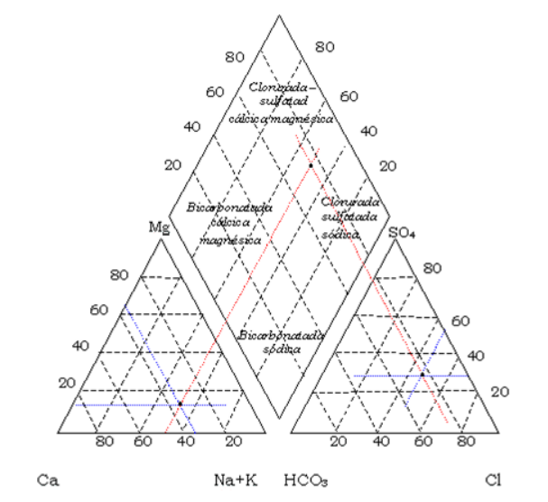

6. Management of water resources.
In the framework of national environmental laws, the issue of water resources has been considered under different perspectives to become what is now known as the Integrated Water Resources Management (IWRM) approach adopted by the National Policy for Integrated Management Water Resources. Such management, according to ECLAC (1992): "... is the process of control that man exerts over the flow of the water in its quantity, quality, place and time of occurrence during the hydrological cycle ...” This management, which seeks to reconcile the water supply with the demand for it, consider the offer of two ways: as manifested in the hydrological cycle (seawater shallow groundwater or meteoric) and from the perspective of the natural system that contains allowing a better understanding of the dynamics leading to a more accurate resource management.
The National Policy for Integrated Water Resources Management, Ministry of Environment and Sustainable Development (2010), in water, is intended to guide the planning, management, tracking and monitoring of water resources at the national level under a management approach comprehensive thereof. It starts from the conception to say that water is a natural property for public use by the State administered by the Regional Autonomous Corporations, Sustainable Development and Urban Environmental Authorities, further recognizing the strategic importance of water to all sectors of society, economic and cultural affairs, and in this sense, integrating this management diagnosis, formulation and implementation of Aquifer Management Plans including aspects of management and conservation through coordinated with local planning regulations and standards associated with planning strategies Urban, along with studies for the knowledge of the aquifer system, its quantity and quality assessment, legal and regulatory issues and threats to the quality and quantity of groundwater.
Groundwater is a resource that the country is just beginning to plan and protect and is still very little is known of it, so, that the Decree 1729 of 2002 regulates the management plans and watershed management, is principal tool for water resource management, although in its Article 11, not are management explicit and less aquifer recharge areas, which establishes the elements required in the diagnosis, defined including areas of recharge as one of the elements that must be identified, defined and localized.
For this reason, in the proposed amendment of Decree 1729 of 2002, which is currently ongoing in the Ministry of Environment and Sustainable Development, states that for those aquifers that are not part of a Plan of Arrangement and a Watershed Management Hydrographic, the competent environmental authority will prepare the Environmental Management Plan Aquifer PMAA, the object will be the planning and management of groundwater through the implementation of programs and projects for the conservation, protection and remediation of the resource, in addition, the competent environmental authority, the territorial entities and other entities of the national, departmental and municipal, settled and responsibilities in the aquifer must order within its powers to invest in the implementation of conservation projects, resource protection and remediation. This is expected to advance the management of the groundwater resource.
Before the Decree 1729 of 2002 and Decree 2811 were 1974, 1541, 1978, 2857, 1981 and Law 99 of 1993, which although not refer to the recharge zones, if you defined a path in the evolution of integrated management of water resources in which the underground resource and recharge areas are included.
Decree 1541 of 1978, but makes no specific reference to areas of recharge, if specific, as a measure for the protection of groundwater, including obligations aimed at protecting this resource in the concessions granted to other activities that do not have as object the use of these waters, such as mining and quarrying, drainage works, lighting gas or hydrocarbons, local cemeteries, waste deposits or contaminants.
Law 99 of 1993, although not intended to regulation of water resources management, considered among the Environmental General Principles to follow local environmental policy (Article 1, paragraph 4): "the areas of moorland, subpáramos, water sources and recharge areas will receive special protection, "being established the importance of recharge areas within national environmental management and compulsory inclusion within environmental policies.
Moreover, in the National Policy for Integrated Water Resource Management (Ministry of Environment and Sustainable Development, 2010), whose focus is the cycle of the Comprehensive Water Resources Management (IWRM), which in turn is based on the hydrological cycle enter groundwater as part of it and as an important element of resource supply in the country, the need to protect and preserve. That is why each of the strategies proposed to achieve the intended result; "he Conserve natural hydrological systems and processes that supply water to the country depends" groundwater is included. Groundwater is also made explicit in most of the strategies of the other goals that are part of the Policy. Recharge areas are not mentioned as a protection strategy but are implicit in the management plans of aquifers, whose guidance being developed by the Ministry of Environment and Sustainable Development.

Conclusions
- A global reality according to which in all countries is enacted and protection of aquifers and recharge areas claimed but in practice very few have materialized initiatives.
- Development pressure on the Aburrá Valley has already urbanization of much of the main recharge areas also important economic activities have disturbed the natural characteristics of the surface through which infiltration and recharge occurs.
- Groundwater is a valuable natural resource and as such should be protected from deterioration and chemical pollution. This is particularly important for groundwater-dependent ecosystems and for the use of groundwater in water supply for human consumption.
- the groundwater resource it is inseparable from surface water resources because it provides baseflow and sustains aquatic life in surface water streams, lakes, and wetlands, as well as in the aquifer itself (such as in karst caves and conduits). Withdrawal of groundwater may affect surface water flows and quality and vice versa
- Strongly related to the ever-increasing public awareness of environmental pollution is a very rapid growth in consumption of bottled drinking water, also across the globe. Many consumers are ready to pay a premium for brands marketed as “pure spring water” or “water coming from deep pristine aquifers,” so that major multinational corporations are frantically looking for groundwater resources that can be marketed as such.
- groundwater in general is much less vulnerable to contamination than surface water; it is generally of better quality and thus requires less investment in water supply development. It is however also true that it usually takes more time and it is more difficult to restore a groundwater source once it becomes contaminated.
- as large-scale groundwater development brings more obvious consequences such as land subsidence, depletion of aquifer storage, and diminished flows of springs and surface streams, the challenge for science and engineering changes from supporting the development of groundwater resources to understanding its sustainability and impact on the environment.
- Given the complexities of water use within society, effective water governance requires the involvement of all stakeholders and must ensure that disparate voices are heard and respected in decisions on development, allocation, and management of common waters, and in using financial and human resources. Governance aspects overlap with the technical and economic aspects of water, but include the ability to use political and administrative elements to solve a problem or exploit an opportunity.

Bibliography

- [1] DETERMINACIÓN Y PROTECCIÓN DE LAS POTENCIALES ZONAS DE RECARGA EN EL NORTE DEL VALLE DE ABURRÁ.. September 2012.
- http://www.areadigital.gov.co/recursohidrico/Publicaciones/Determinacion_y_proteccion.pdf 1) 179 2) 33 3) 109 107 4) 69 70 71 257 5) 159 160 161
- http://www.medellin.gov.co/irj/go/km/docs/wpccontent/Sites/Subportal%20del%20Ciudadano/Medio%20Ambiente/Secciones/Plantillas%20Gen%C3%A9ricas/Documentos/2013/SIGAM/pam/componentefuncionamientoespacial.html calidad
- file:///C:/Documents%20and%20Settings/drai05/Mis%20documentos/Downloads/CAPITULO_1_RECURSOS_NATURALES.pdf
- http://www.corantioquia.gov.co/index.php?option=com_content&view=article&id=527:corantioquia-y-el-agua-en-el-valle-de-aburra&catid=51:campanas&Itemid=272

